

American International University- Bangladesh

CSC 3215: Web Technologies

CO1 and CO2 Evaluation

Project Report

Spring 23-24

Project Title: Advance School Portal (EduNext)

Section: A

Group No:

|  |  |
| --- | --- |
| Student Name | Student Id |
| Ishmam Newaz (Students) | 21-45073-2 |
| Md. Farhan Istiak Piash (Admin) | 21-45052-2 |
| Jannatul Ferdose Tanisha (Teachers) | 20-42669-1 |
| Taiyaba Akther (Canteen Staffs) | 20-43189-1 |

Introduction:

*EduNext Is an Advance School portal designed to revolutionize academic experience for both students and teachers. With its advanced features and modern technology, it aims to make teaching and learning easy while providing the best campus education experience from home. With EduNext, we aspire to redefine traditional education by seamlessly integrating modern tools and resources for optimal learning outcomes and student engagement.*

Background Study

*Our proposed Education Portal was referenced from the below 2 websites:*

1. [*www.aiub.edu*](http://www.aiub.edu) *(AIUB’s official website): This website is the official website for AIUB, providing comprehensive information about academic programs, admission procedures, faculty profiles, campus facilities, and extracurricular activities. It serves as a central hub for students, faculty, staff, and prospective applicants to access important resources and stay updated on university news and events. Studying this website offers insights into the structure, content, and functionalities commonly found in university portals, which can inform the development of features for the proposed advanced school portal project. But it lacks an online food ordering system which we have included in our Portal.*
2. [*www.sgcd.edu.bd*](http://www.sgcd.edu.bd) *(Sabujbah Govt. College’s official website): This is the official website of SGCD. It is also like AIUB’s website providing academic programs, Important notices, teacher profiles, showcases campus life. The website is designed in a way that emphasizes the extracurricular activities of students. By analyzing it we have found that its notice publishing system, extracurricular activity promotion and download options for books is commendable and it has inspired us to implement something similar in our portal too.*

**Requirement Analysis:**

1. **User Category:**

There are 5-types of Users here. They are:

* Administrator
* Teachers
* Students
* Canteen staffs
* Staffs

1. **Feature List: (minimum 12)**

In this project the “User: **Students**” has the following features:

* **Academic Profile viewing:** Students can access their academic profiles, including course schedules, grades, transcripts, and academic history.
* **Subject Management:** Students can view course materials, lecture notes, assignments, and syllabi for each Subjects.
* **Assignment Submission:** Students can view and submit their assignments through the portal.
* **Library Integration:** Students can borrow or return books from the school library directly through the portal. A student can also reserve a book if he/she wants to read it int the future.
* **Online Food Ordering:** A feature allowing students to order food from the campus canteen online. They can browse menus, place orders, and make payments seamlessly through the portal.
* **Resource Center:** Access to a centralized repository of educational resources, including e-books, articles, research papers, and multimedia content, to support learning and research endeavors.
* **Parking Reservation:** A student can parking places for vehicles through the portal
* **Payment System:** A student can pay for tuition fees/parking tickets/food ordering and for other commodities through the portal.
* **Security and Privacy:** The portal is equipped with robust security measures to keep information from breaching and protecting user confidentiality.
* **Support Service:** Students will be able to get support services such as academic advising and counseling through the Portal.
* **Feedback and Surveys:** Students will be able to give feedback on courses, instructors and overall campus experience through surveys and feedbacks through the portal.
* **Progress Tracking:** Students can track their academic progress, including completion status of assignments, quizzes, and exams, as well as monitor their overall progress through the portal.
* **Admission:** Prospective Students can take admission through the portal.

In this project the “User **Admin**” has the following features:

* **User Management:** Admins can manage user accounts, including creating, editing, and deleting accounts for students, teachers, staff, and other administrative personnel.
* **Role-Based Access Control:** Admins can assign roles and permissions to users based on their responsibilities and authority levels, controlling access to different features and functionalities within the portal.
* **Content Management:** Admins can manage and update content on the portal, including announcements, news articles, course materials, and resources, ensuring information accuracy and relevance.
* **Teachers and Staff Management:** Admins can manage Teachers and staff profiles, including hiring, onboarding, training, and performance evaluation processes.
* **Financial Management:** Admins can manage financial aspects such as budget allocation, fee collection, payment processing, and financial reporting.
* **Library Management:** Admins can manage library resources, including book catalogs, digital collections, circulation services, and library user accounts.
* **Canteen Management:** Admins can manage canteen operations, including menu planning, inventory management, vendor relationships, and sales tracking.
* **Communication and Notification Management:** Admins can send announcements, notifications, and alerts to users via email, SMS, or in-app notifications, keeping them informed about important updates and events.
* **Data Security and Privacy:** Admins are responsible for implementing and maintaining robust data security measures, ensuring compliance with data protection regulations, and safeguarding sensitive information.
* **System Configuration and Customization:** Admins can configure system settings, customize portal layouts, themes, and branding elements to align with the institution's identity and preferences.

**ER Design (Ishmam Newaz):**

**ER Design (Farhan Istiak Piash): Admin**

**Tools Used:**

To develop this project, we have used the following:

• draw.io was used to draw ER Diagrams

• Figma was used to design the UI

• Adobe Illustrator was used to Design a professional logo

**Impact of this Project:**

This project significantly enhances accessibility, efficiency, and engagement in education, aligning with modern societal demands for digitalization. It empowers students with streamlined access to resources, promotes personalized learning, and fosters collaboration. By integrating features like online food ordering and library access, it simplifies campus life. Ultimately, the project facilitates a dynamic and inclusive learning environment, bridging gaps in education accessibility and enhancing academic outcomes for all.

**Limitations and Possible Future Improvements:**

Limitations include potential challenges in initial implementation, such as infrastructure constraints and user adoption hurdles. Future improvements could focus on enhancing user experience through AI-driven personalization, expanding accessibility features for diverse learners. Continuous refinement of features based on user feedback and advancements in educational technology will ensure ongoing relevance and effectiveness of the platform.

**System Images against the Specification:**

UI Design (Student and Main page) by **Ishmam Newaz**

**Page-1: Landing Page**

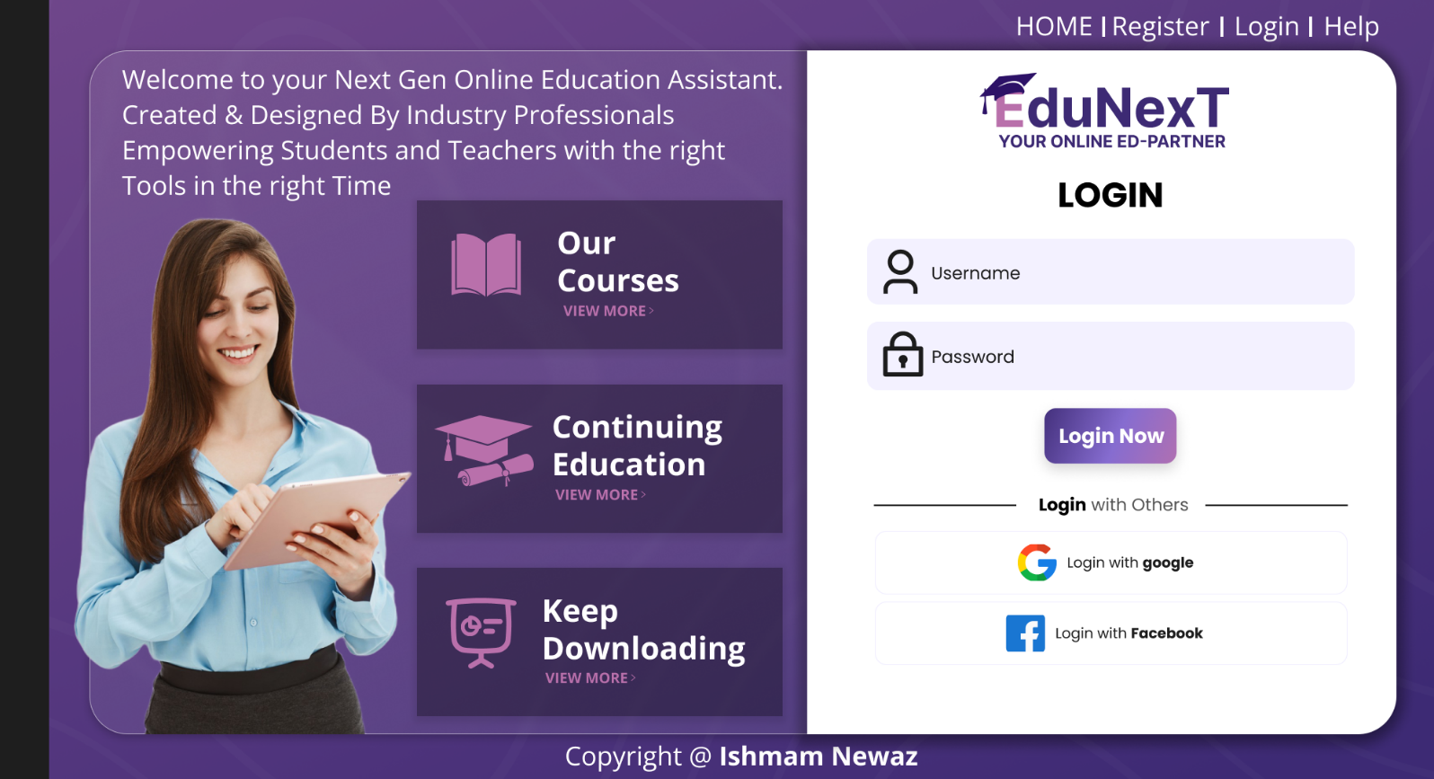**Page-2: Login Page**

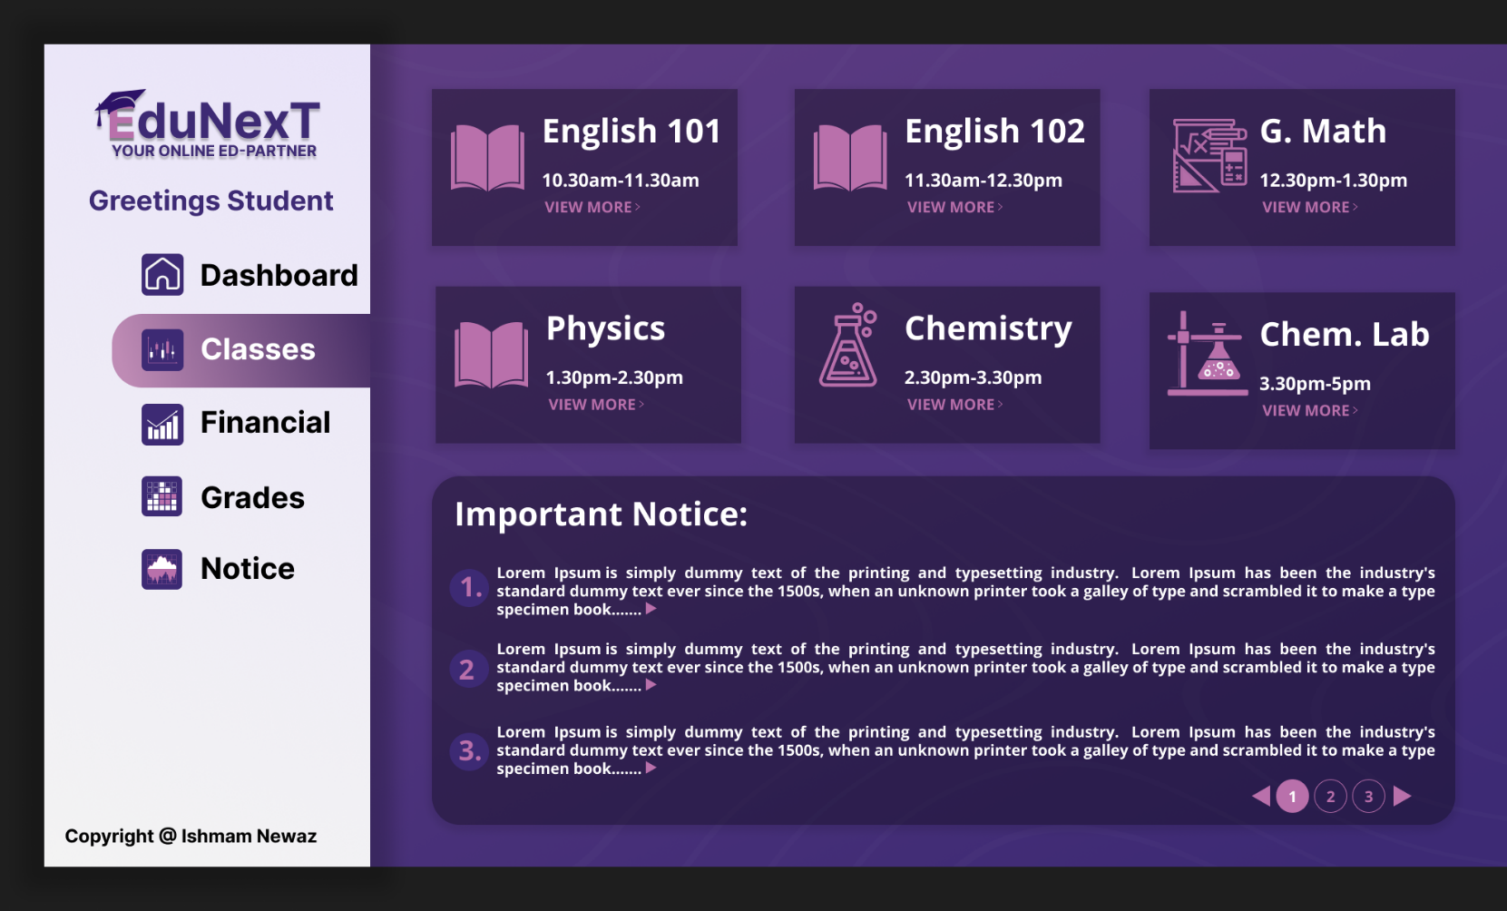**Page-3: Student Page-1 (Classes)**

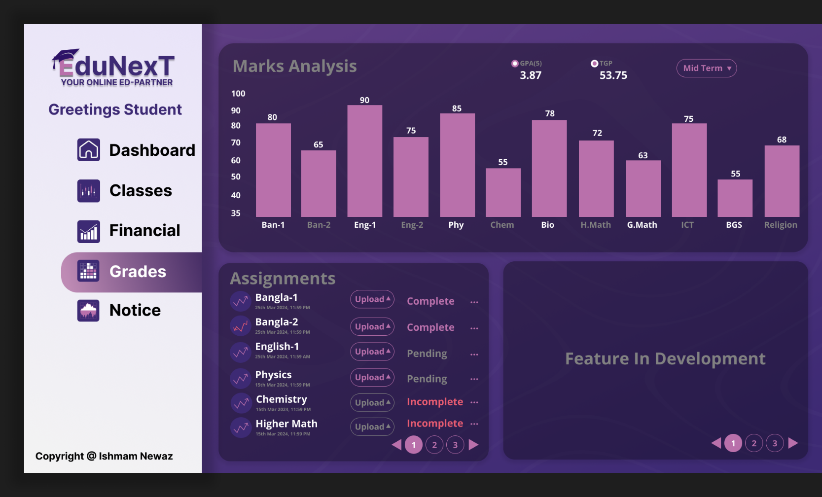**Page-3: Student Page-2 (Grades)**

UI Design (Admin) By **Farhan Istiak Piash**

**Page-1: Admin Dashboard**

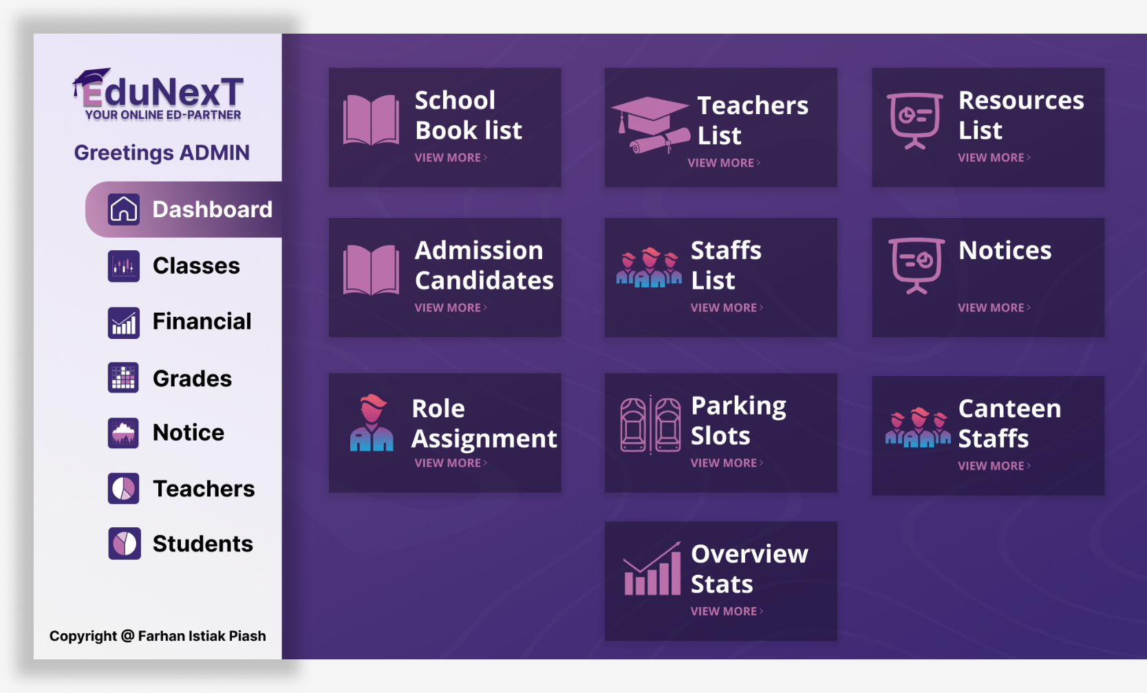

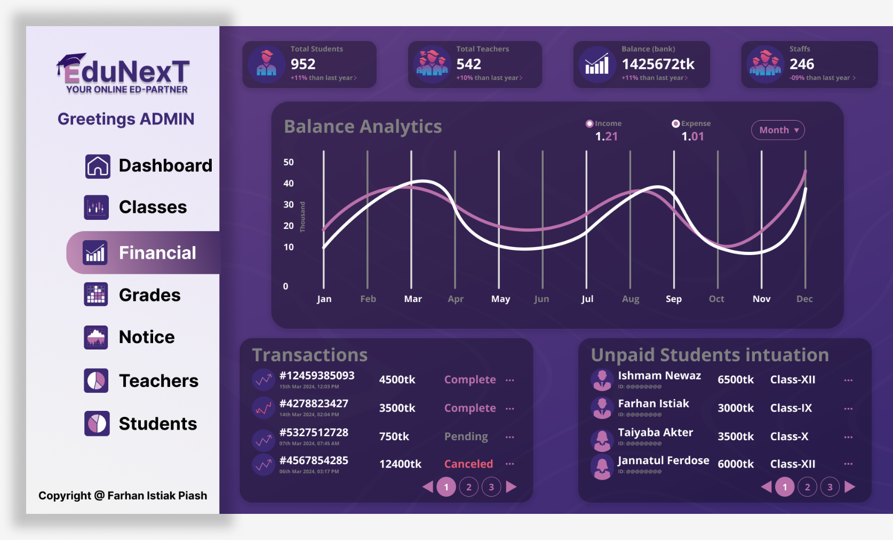**Page-2: Financials**

|  |  |  |  |  |  |
| --- | --- | --- | --- | --- | --- |
| CO1 and CO2 Evaluation: Project Report Evaluation | | | | | |
| Project Proposal  (3) | Background  Study  (3) | Requirement Analysis  (3) | Entity  Diagram  (3) | System Images  against the  Specification (3) | Total (15) |
|  |  |  |  |  |  |
|  | | | | | |